CREATE JAVA APPLICATION

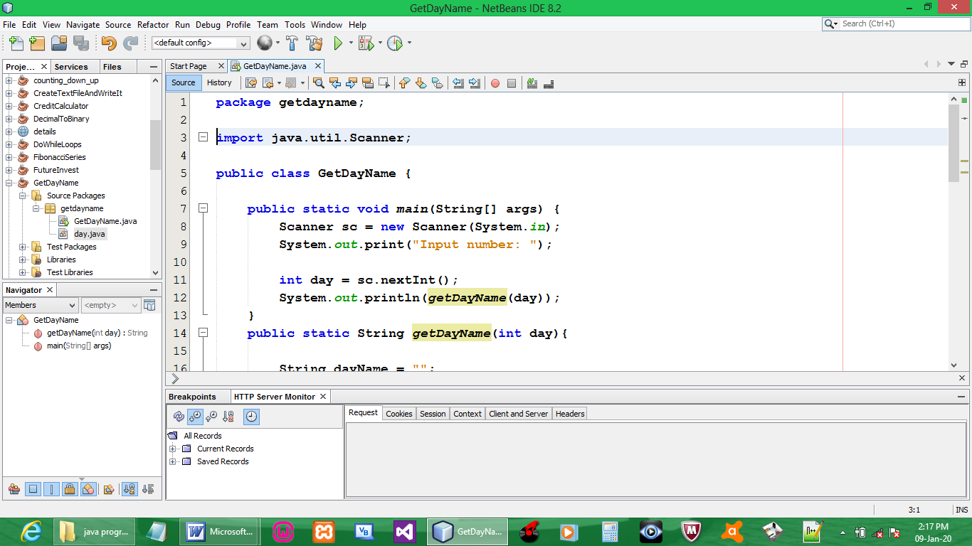

CODE:
package getdayname;

import java.util.Scanner;

public class GetDayName {

public static void main(String[] args) {
Scanner sc = new Scanner(System.in);
System.out.print("Input number: ");

int day = sc.nextInt();
System.out.println(getDayName(day));
}
public static String getDayName(int day){

String dayName = "";
switch(day) {
case 1:
dayName = "Monday";
break;
case 2:
dayName = "Tuesday";
break;
case 3:
dayName = "Wednesday";
break;
case 4:
dayName = "Thursday";
break;
case 5:
dayName = "Friday";
break;
case 6:
dayName = "Satuarday";
break;
case 7:
dayName = "Sunday";
break;
default:
System.out.println("Invalid day range");
break;
}
return dayName;
}
}

OUTPUT:

